# Report 4: System Design Description (SDD)

## 4.1. Design Overview

* This document describes the technical and IU design of the OMCS system. It includes the architectural design and the detailed design of common functions and business functions. It also includes the design of database model.
* The architectural design describes the overall architecture of the system, and the architecture of each main component and subsystem. It will describe the patterns being used, the role of each component and the role of the system in the working environment.
* The detailed design describes static and dynamic structure for each component and function. It includes class diagrams, class explanations, and sequence diagrams of each use cases.
* The database design describes the relationship between entities, and details of each entity.

## 4.2. System Architectural Design

### 4.2.1. Choice of system architecture

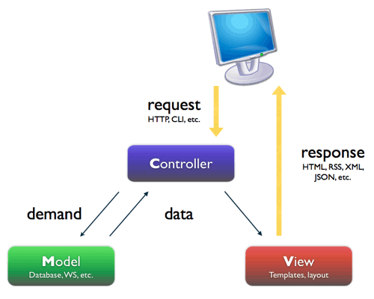

Figure 1: MVC Architecture

**(http://smist08.wordpress.com/tag/mvc/)**

* **The Model** is the part of the application that handles the logic for the application data.  
  Often model objects retrieve data (and store data) from a database.
* **The View** is the parts of the application that handles the display of the data.  
  Most often the views are created from the model data.
* **The Controller** is the part of the application that handles user interaction.  
  Typically controllers read data from a view, control user input, and send input data to the model.

**(**[**http://www.w3schools.com/aspnet/mvc_intro.asp**](http://www.w3schools.com/aspnet/mvc_intro.asp)**)**

### 4.2.2. Discussion of Alternative Designs

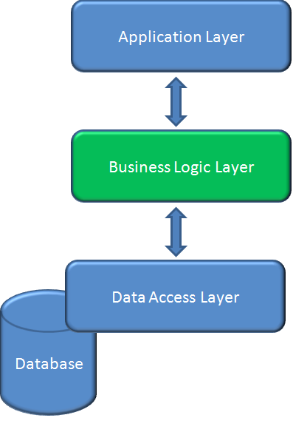

**Figure 2**: Three-layer architecture

* **Data layer:** is basically the server which stores all the application’s data.
* **Business layer:** is mainly working as the bridge between Data layer and Presentation layer. All the data passes through the Business layer before passing to the presentation layer. Business layer is the sum of Business Logic and other components used to add business logic.
* **Presentation layer:** is the layer in which the users interact with an application. Presentation layer contents Share UI code, Code Behind and Designers used to represent information to users.

### 4.2.3. Description of System Interface

### 4.2.3.1. User interfaces

* Because this is a website for medical consulting, so the user interface is simple and friendly.

### 4.2.3.2. Hardware interfaces

* The OMCS is intended as a website runs well on all web browsers. The website should be deployed online and accessible on any computer using different Operation Systems. At present, OMCS does not have mobile version.

### 4.2.3.3. Software interfaces

* The system should be able to run on any browser supported HTML 5.
* Any service exposed by the system should be accessible using HTTP protocol.

### 4.2.3.4. Communication interfaces

* The system uses HTTP protocol to communicate between server and clients.

## 4.3. Component Diagram

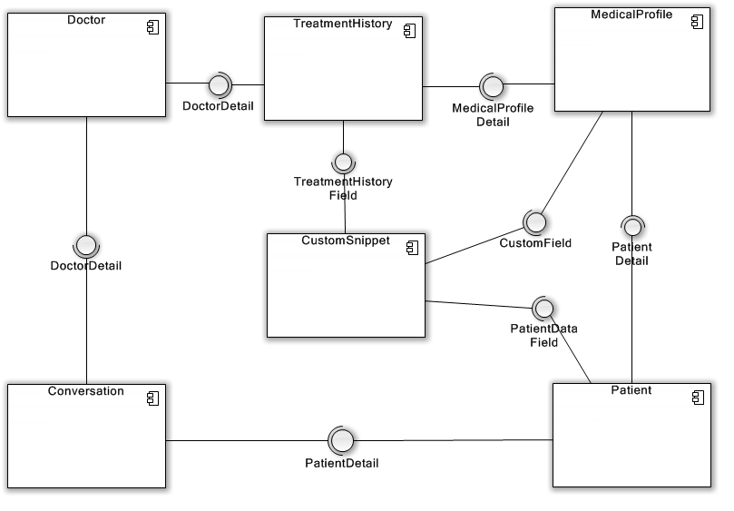

**Figure 3:** Component Diagram

## 4.4. Detailed Description of Components

### 4.4.1. Class Diagram

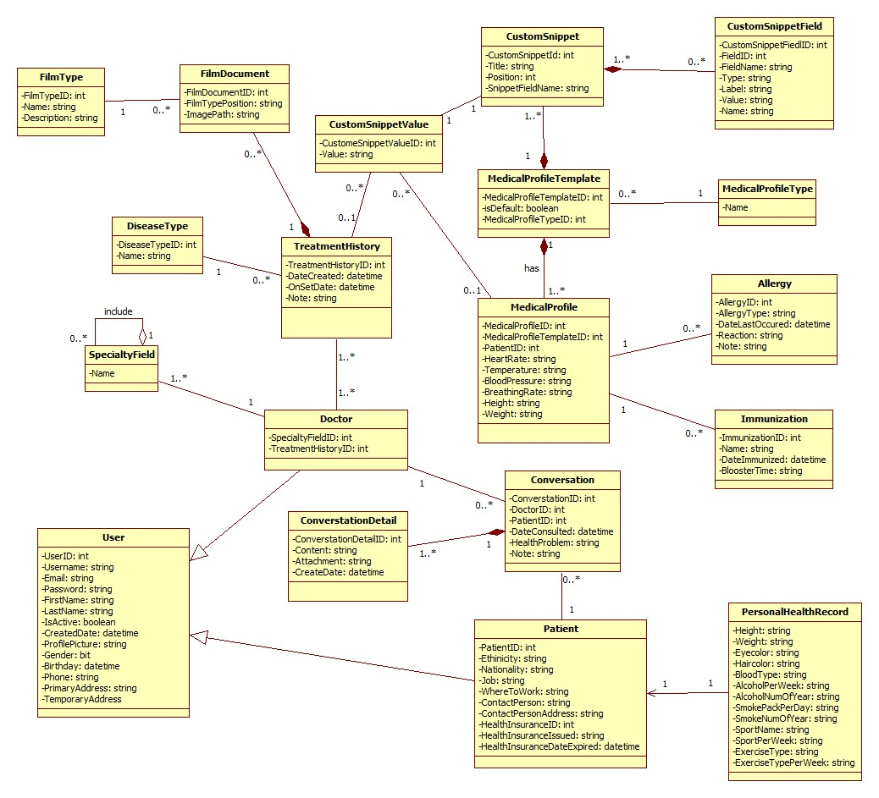

**Figure 4:** Class Diagram

## 4.5. Sequence Diagram

### 4.5.1. Common

### 4.5.1.1. Login

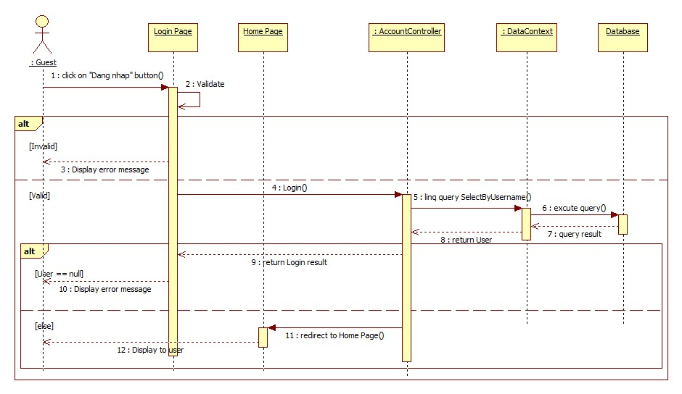

**Figure 5:** Login

### 4.5.1.2. Register

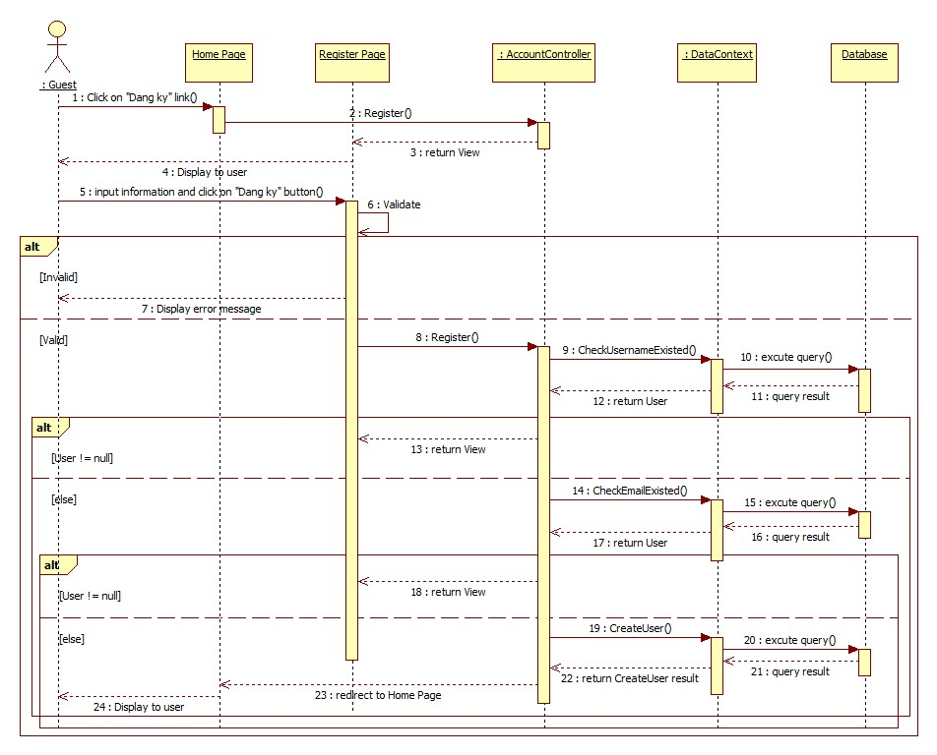

**Figure 6:** Register

### 4.5.2. Update Account Profile

### 4.5.2.1. Change Password

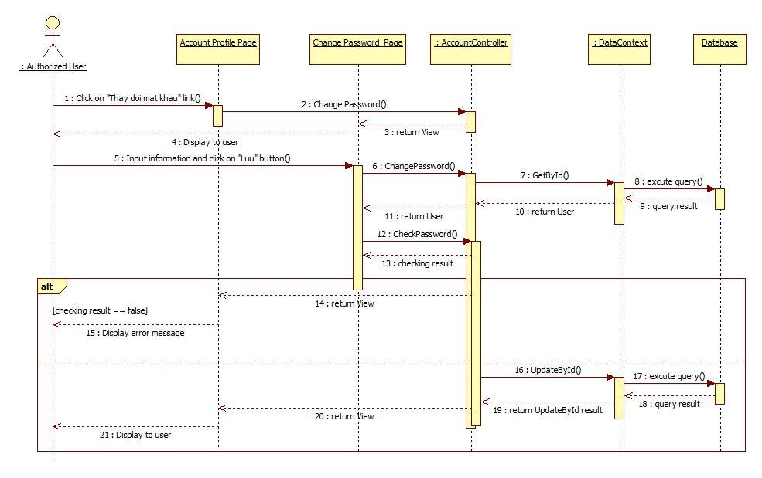

**Figure 7:** Change Password

### 4.5.2.2. Change Profile Picture

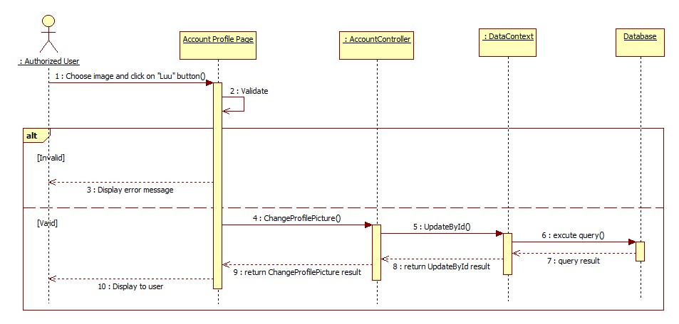

**Figure 8:** Change Profile Picture

### 4.5.3. Consult Online

### 4.5.3.1. Conversation

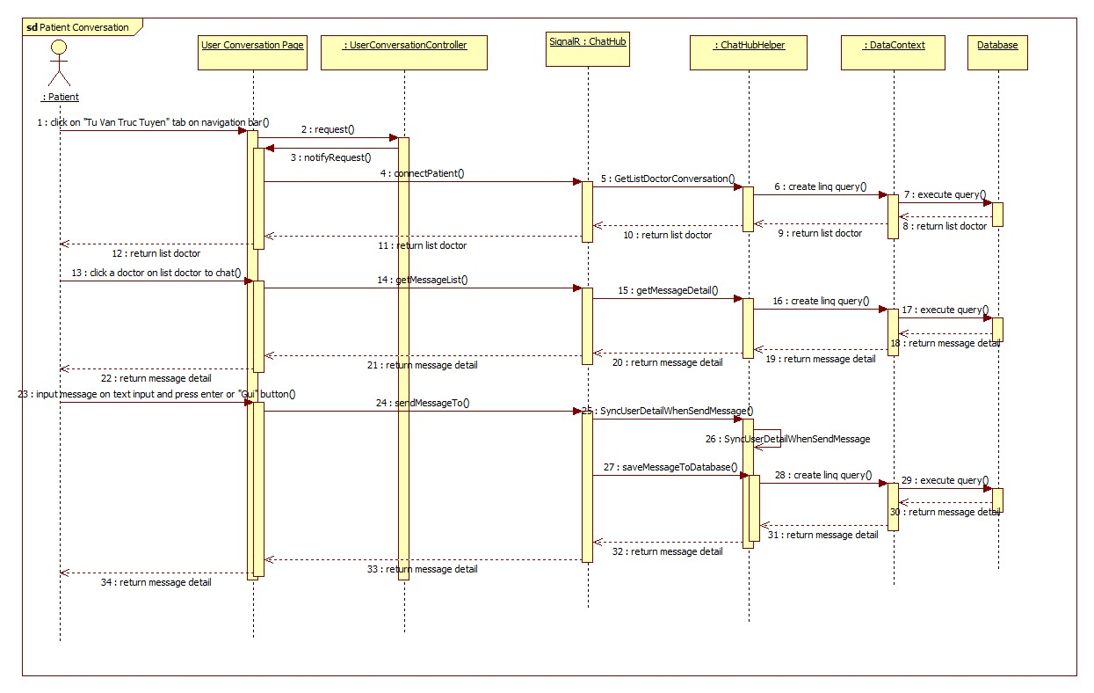

**Figure 9:** Patient Conversation

### 4.5.3.2. Request Webcam

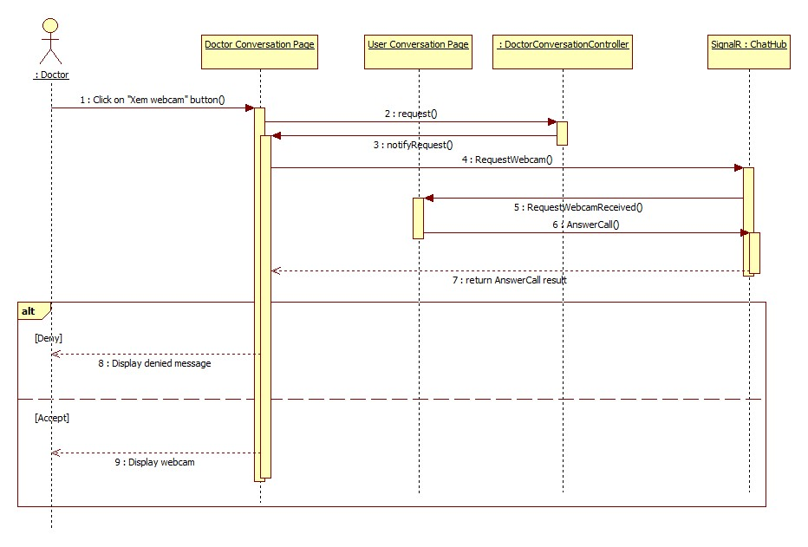

**Figure 10:** Request Webcam

### 4.5.3.3. Show Webcam

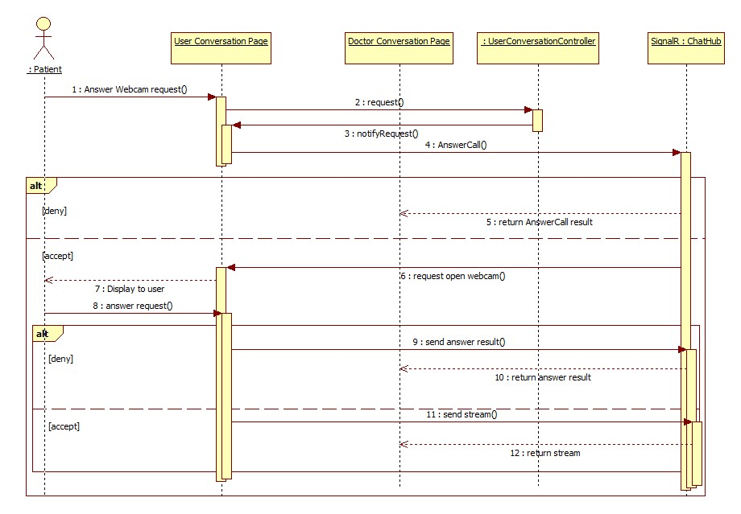

**Figure 11:** Show Webcam

### 4.5.3.4. Upload Attachment

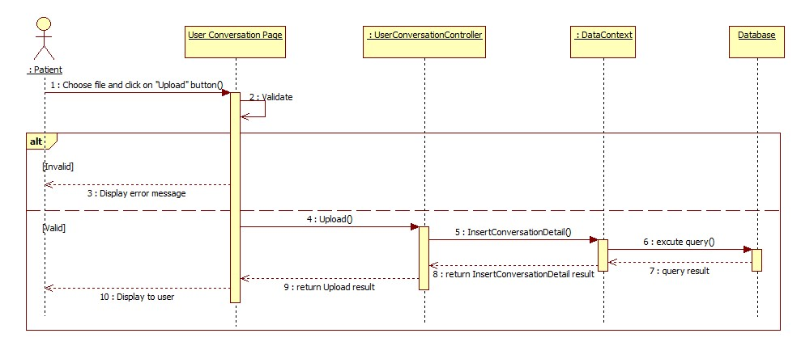

**Figure 12:** Upload Attachment

### 4.5.4. Define New Medical Profile Template

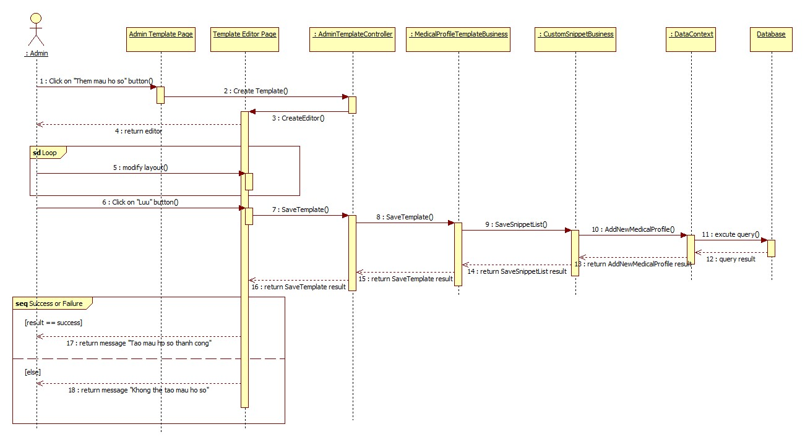

**Figure 13:** Define New Medical Profile Template

### 4.5.5. View Medical Profile Record

### 4.5.5.1. (Patient) View Medical Profile Record

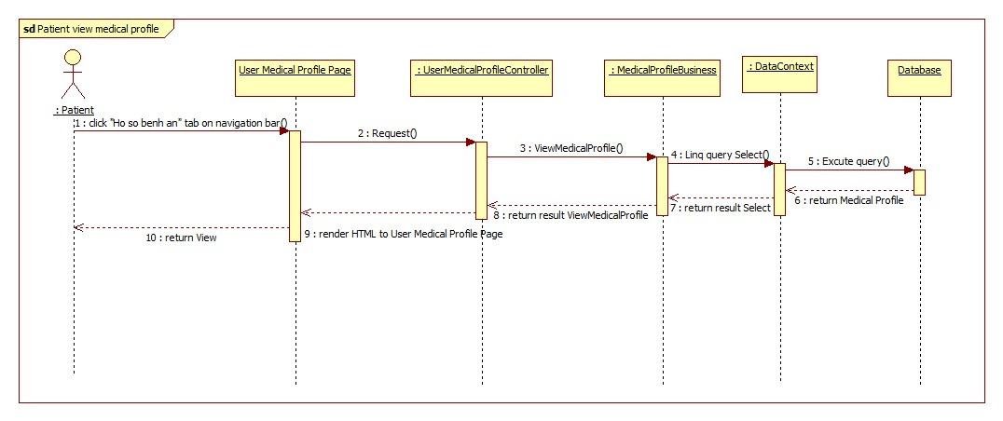

**Figure 14:** (Patient) Views Medical Profile

### 4.5.5.2. Doctor Views Medical Profile Record

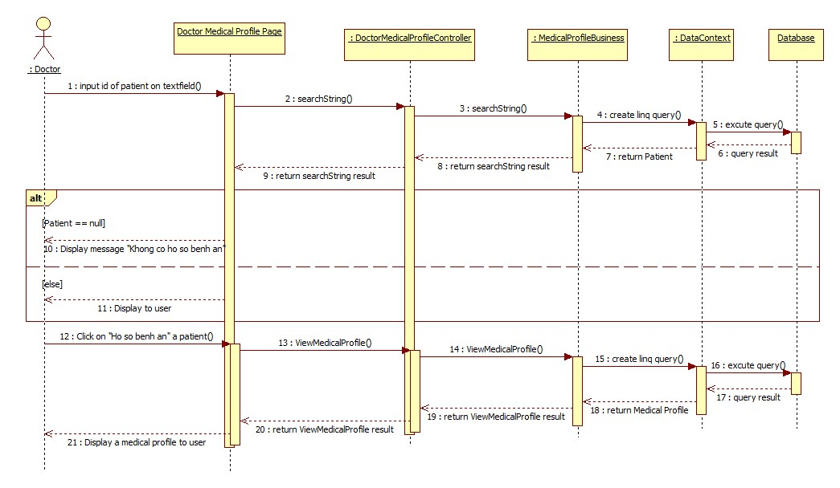

**Figure 15:** (Doctor) View Medical Profile

### 4.5.6. Update Medical Profile

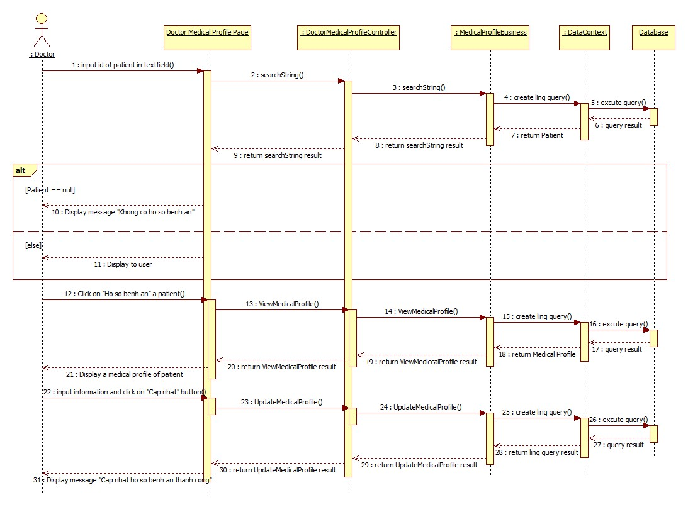

**Figure 16:** Update Medical Profile

## 4.6. Database Design

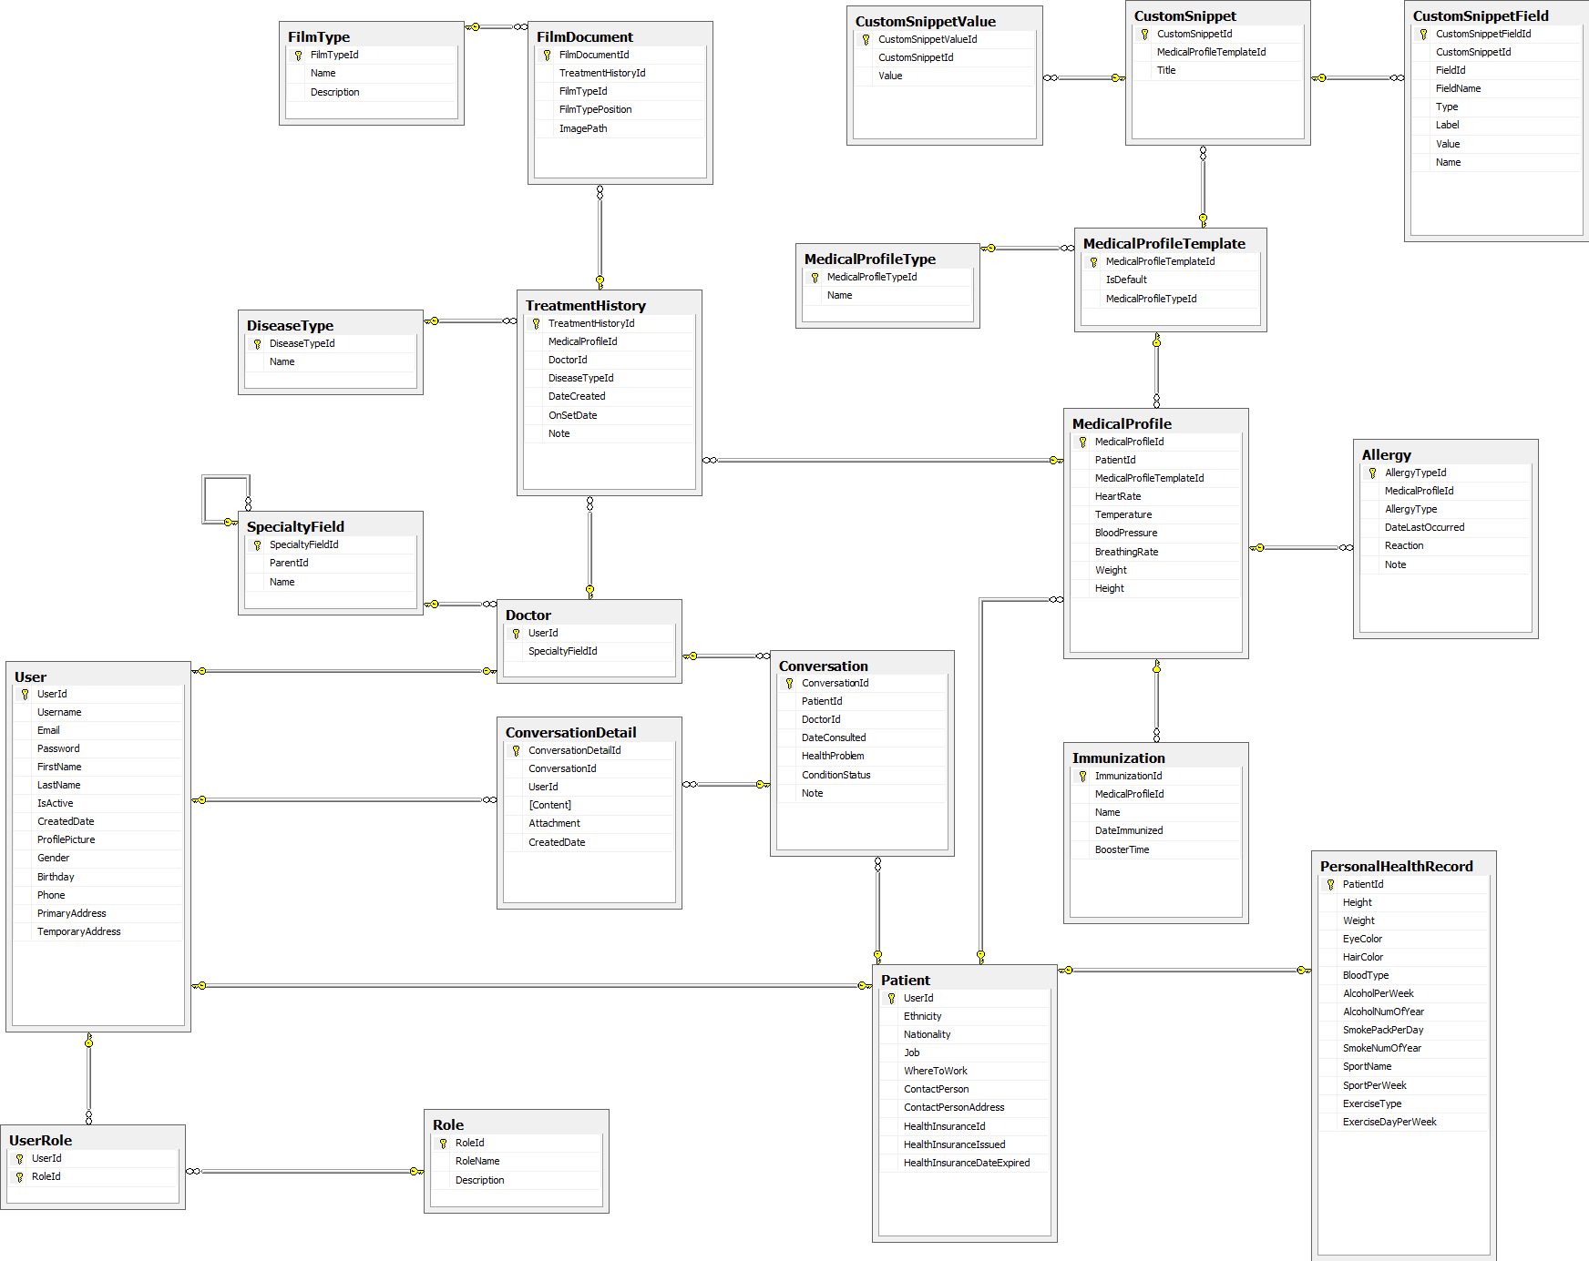

**Figure 17:**

### 4.5.7. Update Personal Health Record

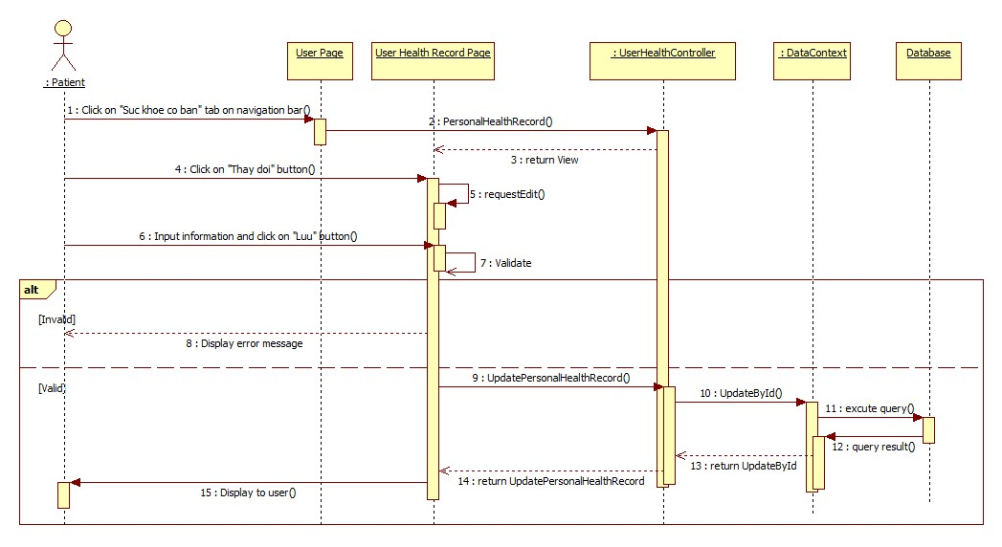

**Figure 17:** Update Personal Health Record